Submitting your ACA AIR File to IRS

Log into e-Services.
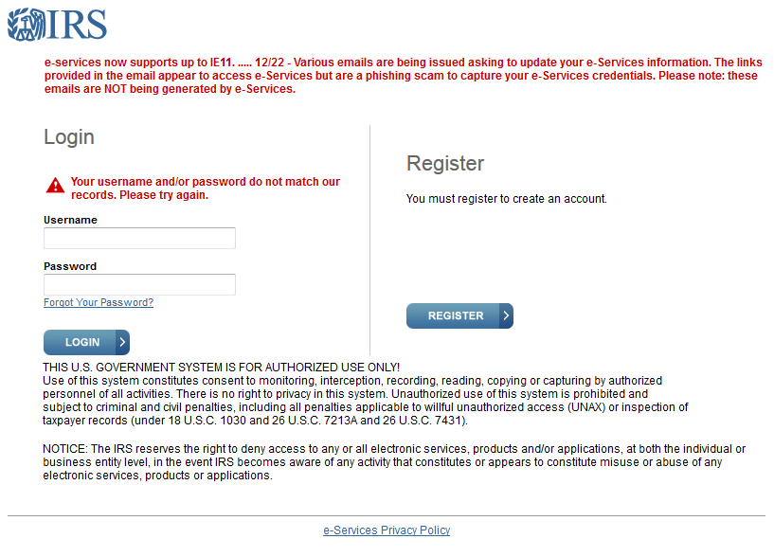
Select the organization for whom you are filing and click Submit Selected Organization.
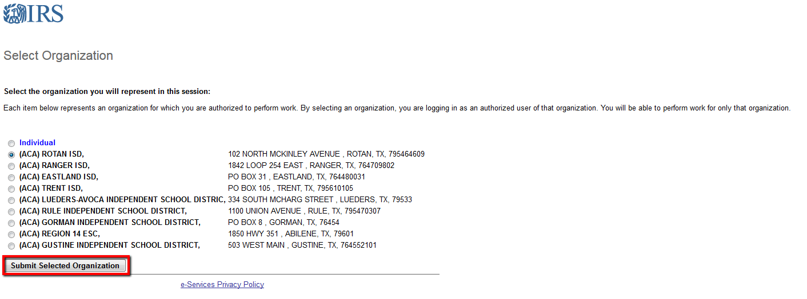

Click the box to Upload ACA Forms.

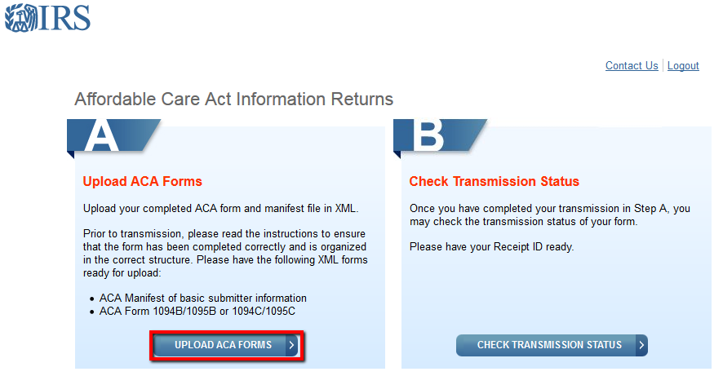
Browse to find the two files saved. One has the word Manifest in the name. That will be uploaded in the Manifest area. The other file is your actual form information. It will be loaded second. Click Transmit.
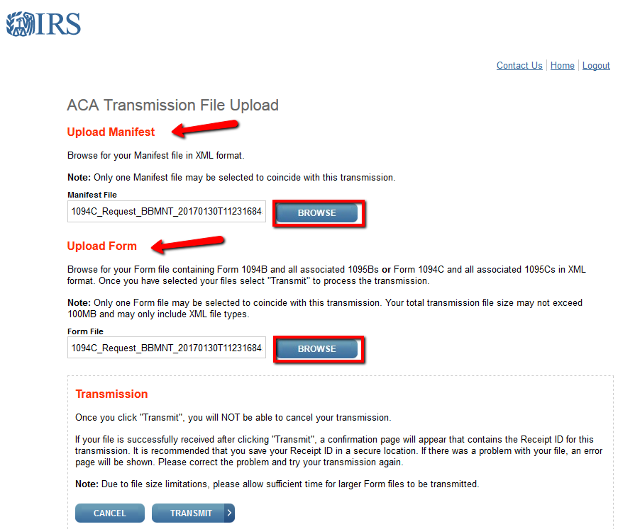
Once the files have been uploaded, you will receive a Transmission Confirmation. Print or save this report as you will need the Receipt ID to check the status of your submission.
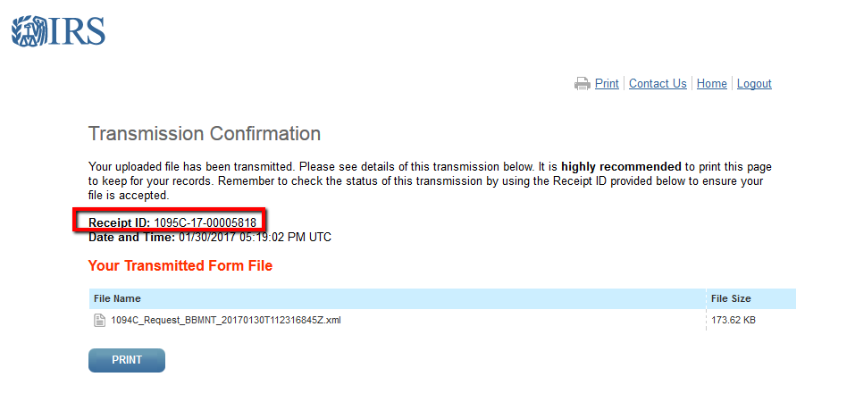

Check back to see if your submission was accepted. Log into e-Services again and select the organization desired. This time select the button to Check Transmission Status.
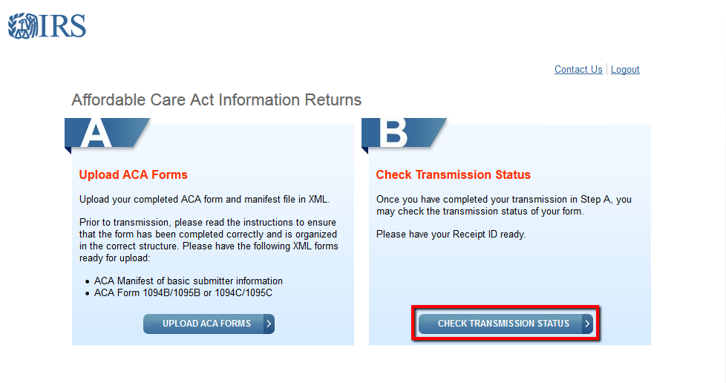

Enter your TCC and Receipt ID received when you submitted your file. Click the Find button.
NOTE: Both the TCC and Receipt ID are case sensitive. The IRS website indicates you must enter the Receipt ID EXACTLY as it was written in your Transmission Confirmation.
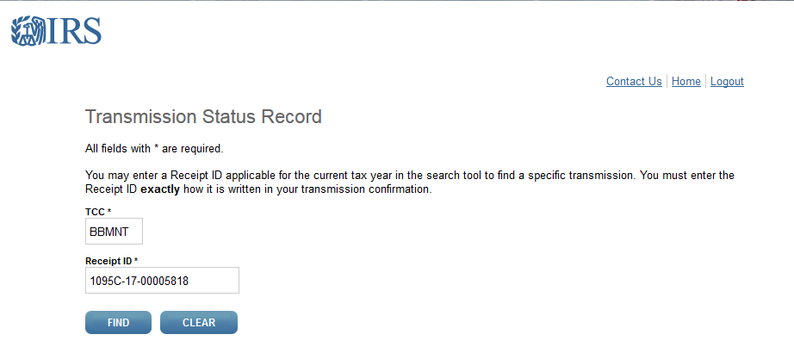

You are checking the Status of your file. Initially it will indicate the file is Loading or Processing. Keep checking back to see when the status changes to Accepted, Accepted with Errors or Rejected.
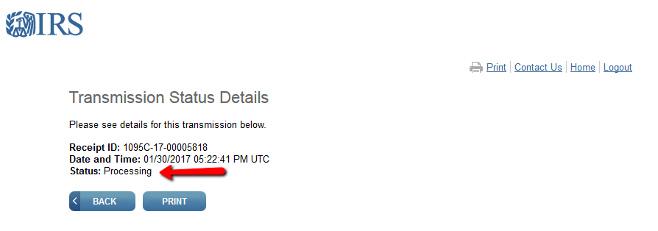

If the file was Accepted, you are finished.
If it was Accepted with Errors or Rejected, refer to our document on correcting errors. It will walk you through the steps to find your error, correct the error and help you determine if you need to send a Correction file or a Replacement file. Do not send another original file.

